Ex.no:8 | MINI PROJECT – SOCIAL MEDIA  DATA ANALYTICS

Domain and Problem Statement:
Domain: Social Media Analytics & Digital Marketing
Problem Statement: Brands and content creators struggle to identify which content types, platforms, and regions actually drive genuine engagement, leading to inefficient ad spend and inconsistent audience growth. This project addresses these challenges by transforming raw post-level engagement data into structured business intelligence across Power BI and Tableau to evaluate content performance, platform-wise reach, and regional engagement trends.
Dataset Description:
Dataset Name: Viral Social Media Trends & Engagement Dataset.
Granularity: Each row represents a single social media post.
Timeframe Covered: 2023 to 2024.
Key Entities & Attributes:
- Post Details: post_id, platform, hashtag, content_type, region.
- Engagement Metrics: views, likes, shares, comments, engagement_level.
- Derived Metrics: total_engagement, engagement_rate.
Data Source:
Primary Source: Kaggle Open Datasets (Viral Social Media Trends and Engagement Analysis).
Storage Infrastructure: Cleaned post-level records hosted within a local MySQL database instance (social_media_analytics).
Architecture:
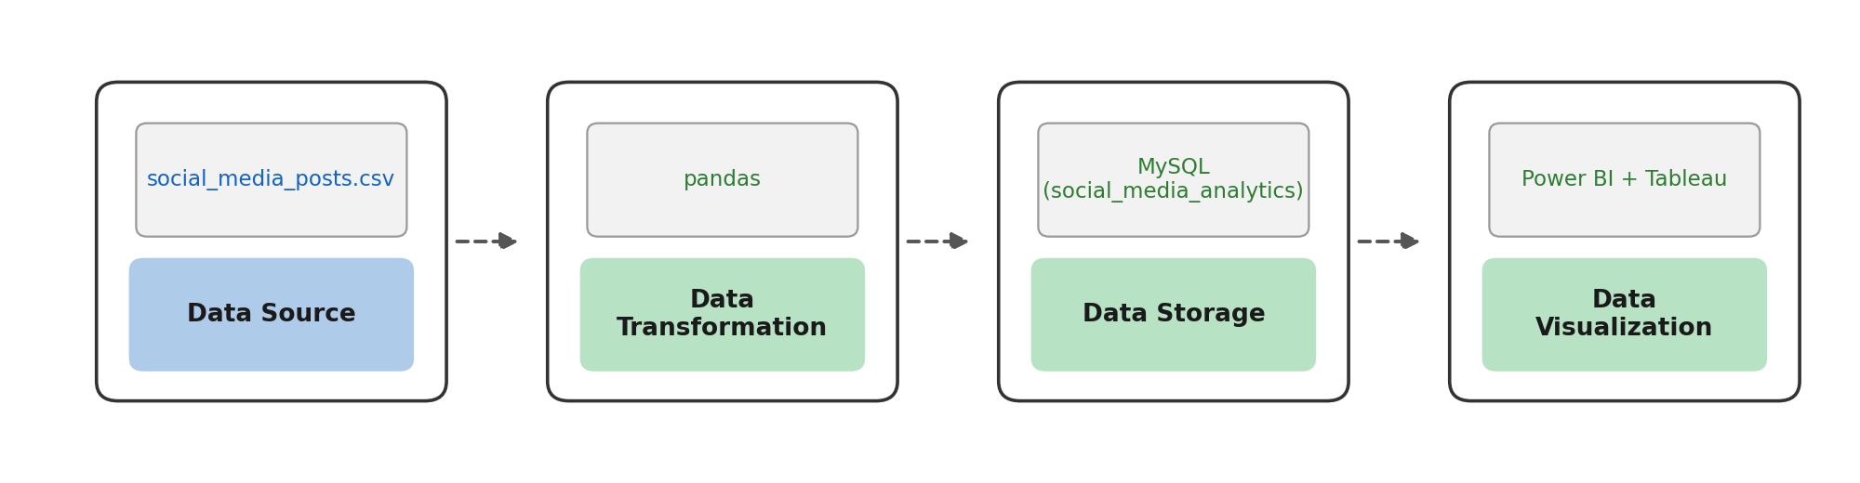

Program:
1. Python – Data Cleaning & Transformation
import pandas as pd
from sqlalchemy import create_engine, text

# Load dataset
df = pd.read_csv("viral_social_media_trends.csv")

# Create a copy for processing
posts = df.copy()

# Standardize column names
posts.columns = (
posts.columns
.str.lower()
.str.strip()
.str.replace(" ", "_")
)

# Handle missing values
posts["hashtag"] = posts["hashtag"].fillna("None")
posts["content_type"] = posts["content_type"].fillna("Unknown")
posts["region"] = posts["region"].fillna("Unknown")
posts[["views", "likes", "shares", "comments"]] = posts[
["views", "likes", "shares", "comments"]
].fillna(0)

# Remove duplicate records
posts.drop_duplicates(inplace=True)

# Filter out invalid rows (zero views)
posts = posts[posts["views"] > 0]

# Derived columns
posts["total_engagement"] = (
posts["likes"] + posts["shares"] + posts["comments"]
)
posts["engagement_rate"] = posts["total_engagement"] / posts["views"]

print("Original Shape:", df.shape)
print("Cleaned Shape:", posts.shape)
posts.head()
2. MySQL – Database and Data Loading
MySQL Command Prompt:
net start MySQL80
mysql -u root -p
MySQL:
CREATE DATABASE IF NOT EXISTS social_media_analytics;
Python/Jupyter:
username = "root"
password = "YOUR_MYSQL_PASSWORD"
host = "localhost"
port = 3306

# Connect to MySQL database
db_engine = create_engine(
f"mysql+pymysql://{username}:{password}@{host}:{port}/social_media_analytics"
)

# Load cleaned data into MySQL
posts.to_sql(
"social_posts",
con=db_engine,
if_exists="replace",
index=False,
chunksize=5000,
)

print("Data loaded successfully into MySQL.")
Verify:
pd.read_sql(
"SELECT COUNT(*) AS total_rows FROM social_posts",
db_engine
)

Procedure:
Step 1: Data Preparation & Preprocessing (Python / Pandas)
- Load the raw Kaggle dataset into a Jupyter Notebook / Python script using pandas.read_csv().
- Inspect for null values and handle missing data in hashtag, content_type, and region columns.
- Feature engineer total engagement and engagement rate:
total_engagement = likes + shares + comments
engagement_rate = total_engagement / views
- Filter out invalid rows (e.g., zero views) and export the cleaned DataFrame to MySQL using sqlalchemy and to_sql().
Step 2: SQL Database Connection & Data Ingestion
- Open Power BI Desktop → Click Get Data → Select MySQL Database.
- Enter the Server (localhost:3306) and Database Name (social_media_analytics).
- Enter authentication credentials, select the cleaned flat table (social_posts / social_media_analytics), and click Transform Data to open Power Query.
Step 3: Star Schema Data Modeling (Power BI)
- Table Splitting in Power Query:
  - Duplicate the imported flat table (social_posts) three times to create separate entities: Fact_Posts, Dim_Content, Dim_Platform, and Dim_Region.
  - In Dim_Content, keep content_type and hashtag. Remove duplicates and add an Index Column as ContentID.
  - In Dim_Platform, keep platform. Remove duplicates and add an Index Column as PlatformID.
  - In Dim_Region, keep region. Remove duplicates and add an Index Column as RegionID.
  - In Fact_Posts, merge with dimension tables to map ContentID, PlatformID, and RegionID, then remove raw text columns.
  - Click Close & Apply.
- Establishing Relationships in Model View:
  - Open the Model View tab in Power BI.
  - Connect Dim_Content[ContentID] → Fact_Posts[ContentID] (1:∗).
  - Connect Dim_Platform[PlatformID] → Fact_Posts[PlatformID] (1:∗).
  - Connect Dim_Region[RegionID] → Fact_Posts[RegionID] (1:∗).
  - Hide foreign key columns inside Fact_Posts to keep the report fields pane organized.
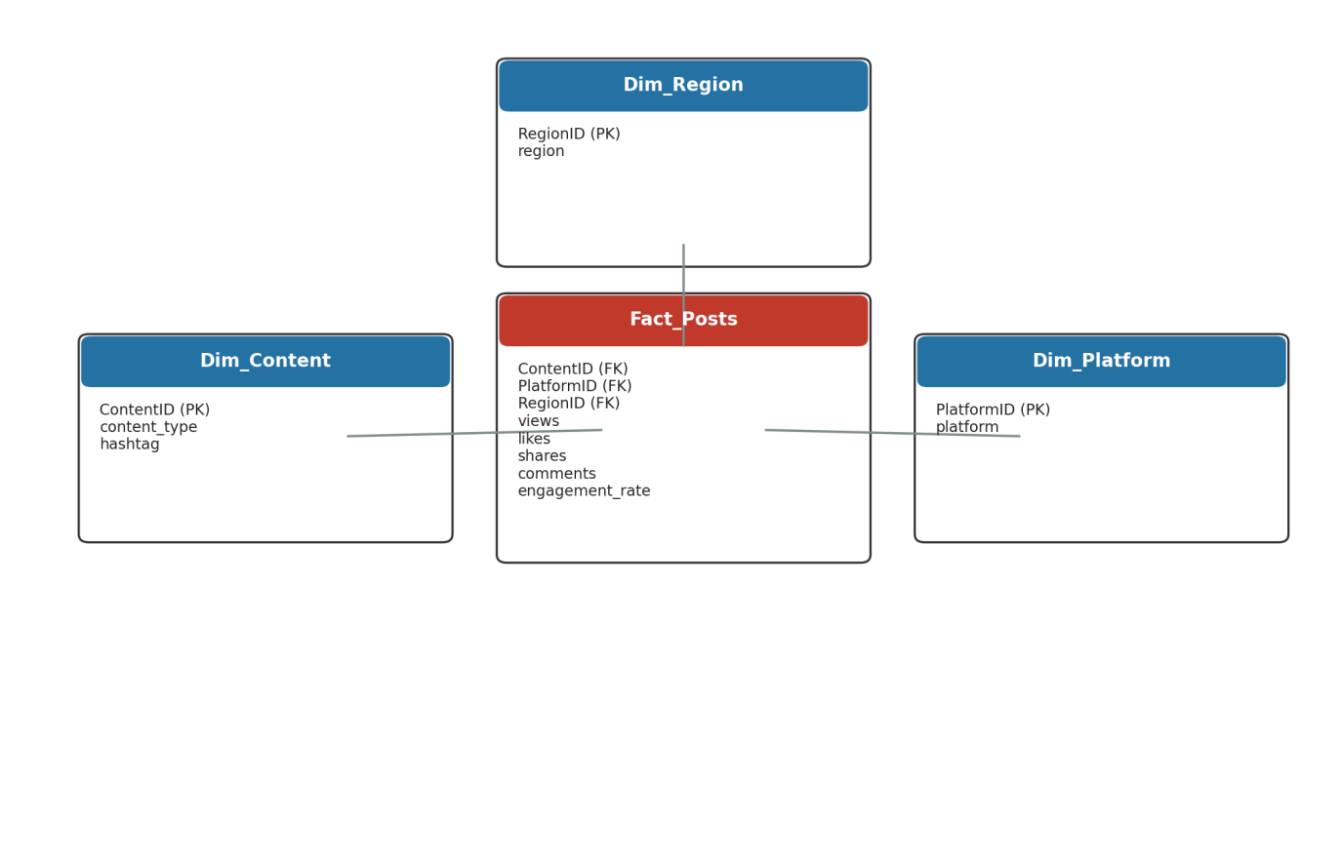
Star schema model — Fact_Posts with Dim_Content, Dim_Platform, and Dim_Region.

Step 4: Core Calculations & Measures (DAX)
Create a dedicated _Measures table and add the following DAX calculations:
- Total Posts:
Total Posts = COUNTROWS(Fact_Posts)
- Total Views:
Total Views = SUM(Fact_Posts[views])
- Total Engagement:
Total Engagement =
SUMX(
Fact_Posts,
Fact_Posts[likes] + Fact_Posts[shares] + Fact_Posts[comments]
)
- Engagement Rate (%):
Engagement Rate =
DIVIDE([Total Engagement], [Total Views], 0)
- Average Likes per Post:
Average Likes per Post = AVERAGE(Fact_Posts[likes])
Step 5: Power BI Final Executive Dashboard & Drill-Through
- Executive Canvas:
  - Place Card Visuals across the top: Total Posts, Total Views, Engagement Rate, Average Likes per Post.
  - Add a Line Chart mapped to Dim_Date/post date with hierarchy drill-down enabled (Year → Quarter → Month).
  - Add a Clustered Bar Chart for Total Posts by content_type.
  - Add a Donut Chart for Total Views by platform.
  - Add Slicers for platform and region.
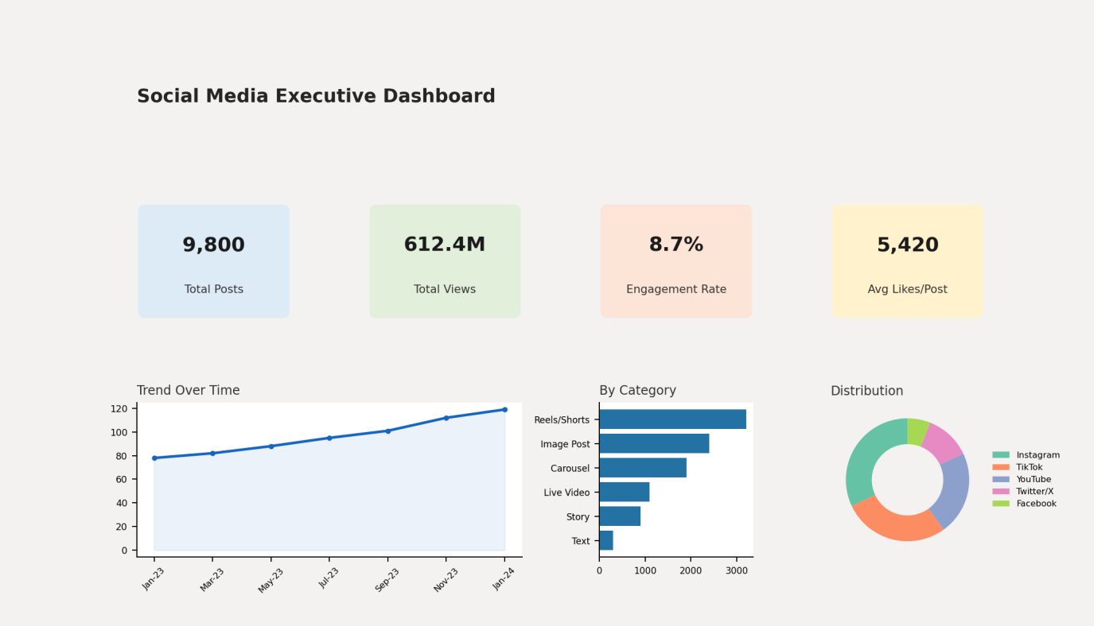
Illustrative layout of the Power BI executive dashboard (cards, trend line, content-type and platform-share charts).
- Region Details Drill-Through Page:
  - Create a second page named Region Details.
  - Drag Dim_Region[region] into the Drill-through field bucket.
  - Add a detailed Matrix/Table visual showing region, Total Posts, Total Views, and Engagement Rate.

Step 6: Tableau Data Connection & Preparation
- Open Tableau Desktop / Tableau Public.
- Under To a Server, select MySQL.
- Enter Server (localhost), Database (social_media_analytics), and user credentials to pull the cleaned dataset onto the canvas.
- Go to any sheet and build calculated fields:
  - Total Engagement
SUM([Likes]) + SUM([Shares]) + SUM([Comments])
  - Engagement Rate
[Total Engagement] / SUM([Views])
  - Average Views per Post
AVG([Views])
  - Select Platform Metric Parameter: String list containing "Total Engagement", "Engagement Rate", "Average Views per Post".
  - Dynamic Metric Formula:
CASE [Select Platform Metric]
WHEN 'Total Engagement' THEN [Total Engagement]
WHEN 'Engagement Rate' THEN [Engagement Rate]
WHEN 'Average Views per Post' THEN [Average Views per Post]
END
Step 7: Tableau Companion Dashboard & Interactive Story
- Worksheets: Build KPI Cards, Dynamic Metric Trend Line Chart, Platform Breakdown Bar Chart, and Region Map.
- Global Filters & Actions:
  - Drag platform, content_type, and region to Filters → set to Apply to Worksheets → All Using This Data Source.
  - Add a Parameter control for Select Platform Metric to the dashboard.
  - Drag sheets onto a new Dashboard tab and click the Use as Filter funnel icon on the Region Map visual.
- Drill-down map: Clicking a region on the map filters the KPI cards, trend line, and platform bar chart to that region's posts.
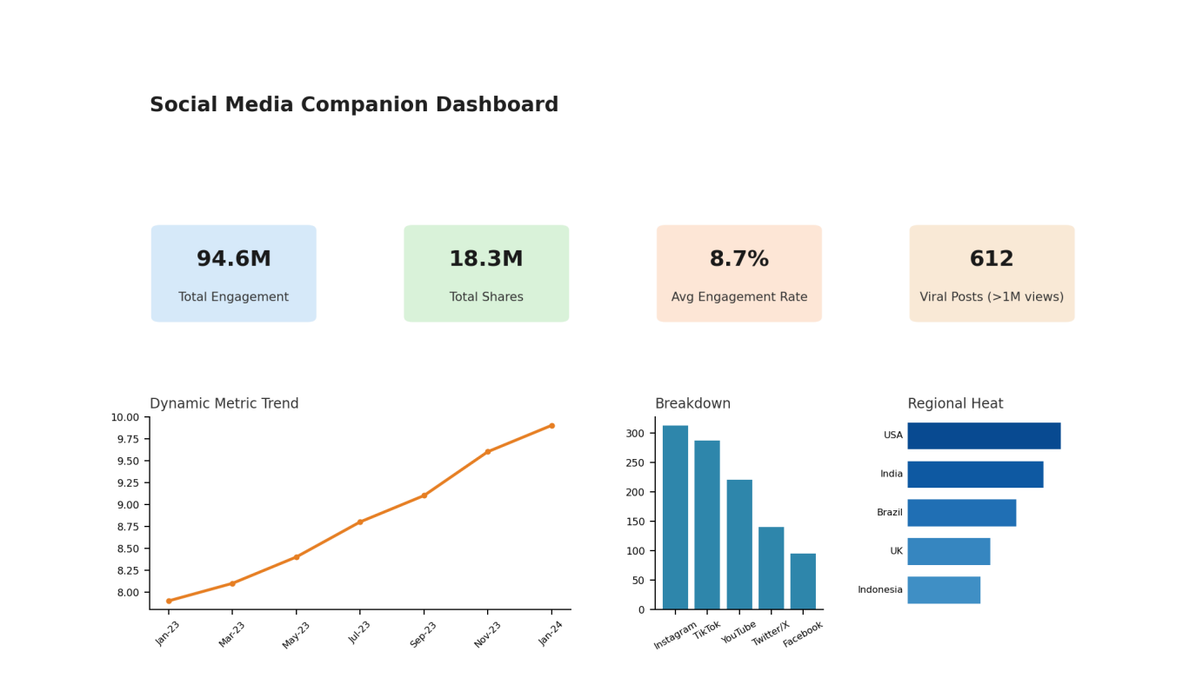
Illustrative layout of the Tableau companion dashboard (KPI sheet, dynamic metric trend, platform breakdown and regional heat).
Observed Insights:
- Portfolio Reach & Volume: The dataset captures approximately 9,800 Total Posts generating 612.4M cumulative Views, with an overall Engagement Rate of 8.7%.
- Content Performance: Reels/Shorts and Image Posts drive the largest share of post volume and engagement, significantly outperforming static text-only posts.
- Platform Distribution: Instagram and TikTok together account for the majority of views, followed by YouTube, Twitter/X, and Facebook.
- Growth Trend: Engagement volume shows a steady upward trend across the observed months, indicating growing audience interaction over time.
- Regional Concentration: The USA and India lead in post engagement volume, followed by Brazil, the UK, and Indonesia, highlighting where campaign spend is likely to have the greatest reach.

